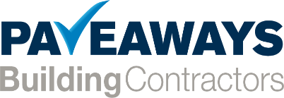

Pave Aways Limited is a successful privately-owned construction business. We are passionate about delivering quality results on time, safely and on budget. We employ approximately 100 members of staff, with our main office based near Oswestry, Shropshire.
JOB DESCRIPTION
Job Title | Accounts/HR Assistant
Reports to | Charlotte Davies/Jane Harvey

Job Overview
This is a varied role, with opportunity to gain experience and knowledge in both the Accounts and HR department. You will be based in the accounts office and your time will be split between the two departments.

- Collation of timesheets weekly/monthly
- Cover payroll position when required
- Assisting with accounts queries – payroll and purchase ledger
- Statement reconciliation/query resolution
- Disseminate Construction Industry Scheme (CIS) statements
- Checking Sub-contractor Insurances
- Setting up new sub-contractor and supplier accounts
- Setting up new employee starters on the system and scanning in paperwork
- DBS checks
- Driving licence checks
- Monitor the Vehicle Tracking system
- Ensuring all employee information is up to date
- Dealing with employee queries

As Accounts/HR Assistant you will be expected to have
- Proficient in Sage Accounts, Sage Payroll and Microsoft Office
- 3 years’ experience working in an accounts position
- Excellent interpersonal skills – to deal with customers and external contacts
- Good organisational skills
- Ability to maintain high levels of confidentiality

- Salary and hours
- 24 hours per week
- Salary is dependent on experience

